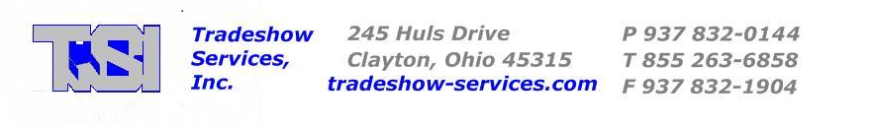

Dear Air Force Marathon Expo Exhibitor,

Tradeshow Services, Inc. has been selected again this year as your Show Decorator and to handle Inbound/Outbound Freight for the 2015 Air Force Marathon Expo at the Wright State University Nutter Center.

Each booth comes with (1) 8’ Back Drape, (2) 3’ Side Rails, (1) Identification Sign, (1) 6’ Skirted Table, (2) Chairs and (1) Waste Basket.

Electricity will automatically be provided for vendors by the Wright State University Nutter Center at no charge.

To obtain Drayage & Shipping Forms or to rent Carpet, Additional Tables, Chairs, etc., visit our website at www.tradeshow-services.com. You will need a Username and Password:

Username: tradeshowexhibitor
Password: tr88ex99

Advance Pricing Deadline Date is September 9, 2015. Any orders received after Deadline Date will be charged the Floor Price as noted on each form.

All orders must be accompanied with full payment. Forms can be faxed or emailed to: debbie@tradeshow-services.com. If you are paying by check, checks must be received to our office by Deadline Date.

If you have any questions, please call our office at (937) 832-0144 or Toll Free at (855) 263-6858.

Thank You!

Tradeshow Services, Inc.

